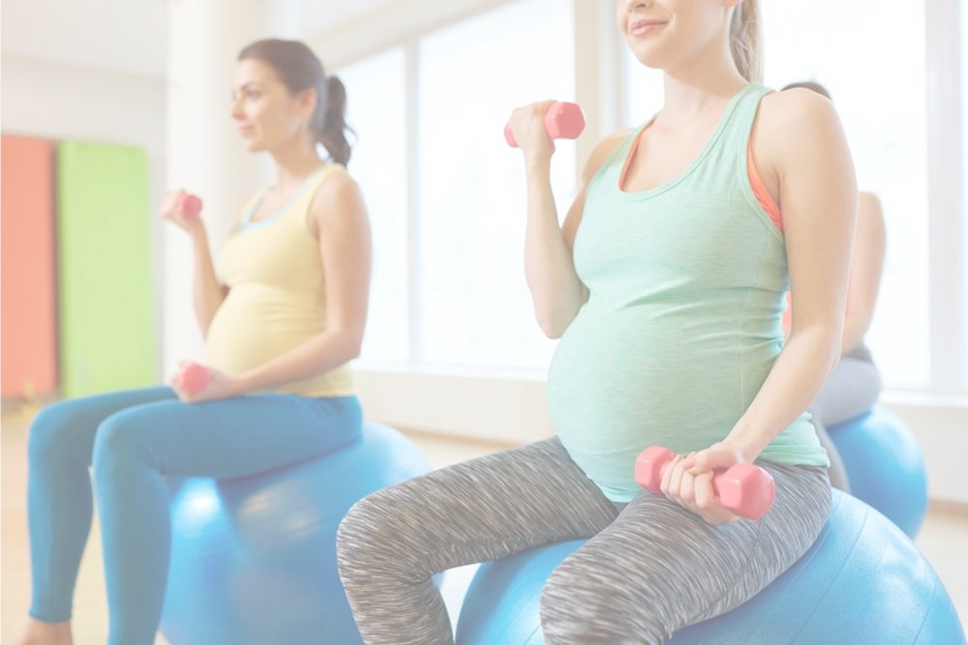

**What to Avoid During Pregnancy**

**[Insert Date and Time]**

Please join us to learn a little bit about what to avoid during pregnancy. The gathering will provide useful information and an opportunity to discuss the following topics with [insert audience]:

* Substances to Avoid While Pregnant
* Foods to Avoid While Pregnant
* Physical Activities to Avoid While Pregnant

*If you or someone you know would like support with substance misuse, please call* ***Partnership for Healthy Mothers and babies at (909) 383-3022.***

**Presented by [name], [organization]**

Insert two sentence biography of subject matter expert.

This information is made available in part by support from the Maternal Health Network of San Bernardino County. Published in 2021. To learn more about the MHN, please visit our website at [www.maternalhealthnetworksb.com](http://www.maternalhealthnetworksb.com).

**Insert Logo and/or Picture of Presenter**