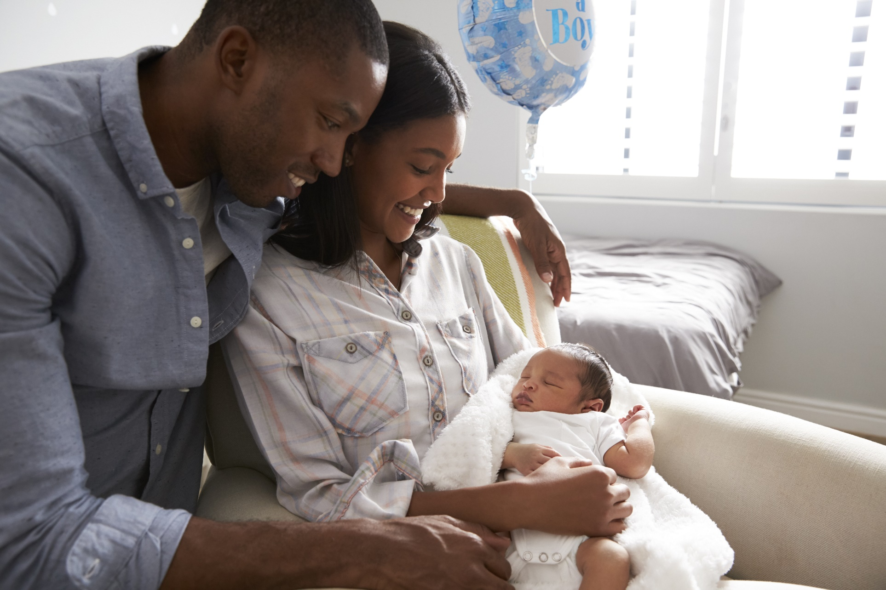**`**

**3**

**Things to Know about What to Expect after Delivery**

**Emotional Changes**

*It is common to feel a range of emotions after delivery.*

* ***Baby blues*** *are experienced by many birthing individuals in the two weeks following delivery.*
* ***Postpartum depression*** *is a more serious condition that often requires treatment.*

**Changes in Your Body**

*Many physical changes will occur after delivery, and these can vary depending on the type of delivery you had and whether you are breastfeeding.*

*It is important to take care of yourself, eat well, drink lots of water, and rest so your body can heal.*

**Postpartum visits**

***Postpartum care is an on-going process.***

*At these visits, your provider will check your physical health and healing and ask about your emotional well-being.*

*Before your appointment, make a list of questions you want to ask your provider.*

**3**

**2**

**1**

This information is made available in part by support from the Maternal Health Network (MHN) of San Bernardino County in partnership with **[insert partner name]**. Published in 2022.

To learn more about the MHN, please visit our website at [www.maternalhealthnetworksb.com](http://www.maternalhealthnetworksb.com).

**INSERT PARTNER LOGO**

**Presented by [name], [organization]**

Insert two sentence biography of subject matter expert.