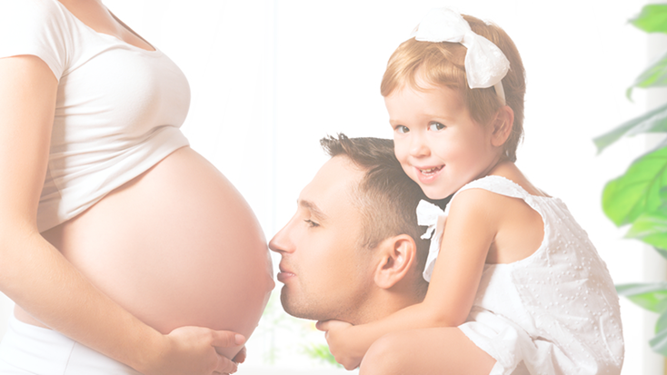**can`**

**Benefits for Mom**

*Pregnancy is hard work! Taking time to heal your body and recover from pregnancy and childbirth supports healthy pregnancies in the future.*

*Waiting* ***18 months*** *after birth to get pregnant again can help prevent* ***premature birth, low birthweight,*** *and* ***miscarriage*** *in your next pregnancy.*

**2**

**Things to Know about Why Birth Spacing Matters**

**3**

**3**

**Benefits for Baby**

*Waiting* ***18 months*** *to get pregnant can help your next child grow to full term, which increases:*

* *healthy brain development*
* *healthy physical development*

*Birth spacing can also decrease your next baby’s risk of chronic health issues associated with pre-term birth.*

**What is Birth Spacing?**

*Birth spacing is the time between the birth of a child and your next pregnancy.*

*Doctors recommend waiting at least* ***18 months*** *after you give birth to your child to get pregnant again.*

**1**

This information is made available in part by support from the Maternal Health Network (MHN) of San Bernardino County in partnership with **[insert partner name]**. Published in 2022.

To learn more about the MHN, please visit our website at [www.maternalhealthnetworksb.com](http://www.maternalhealthnetworksb.com).

**INSERT PARTNER LOGO**

**Presented by [name], [organization]**

Insert two sentence biography of subject matter expert.