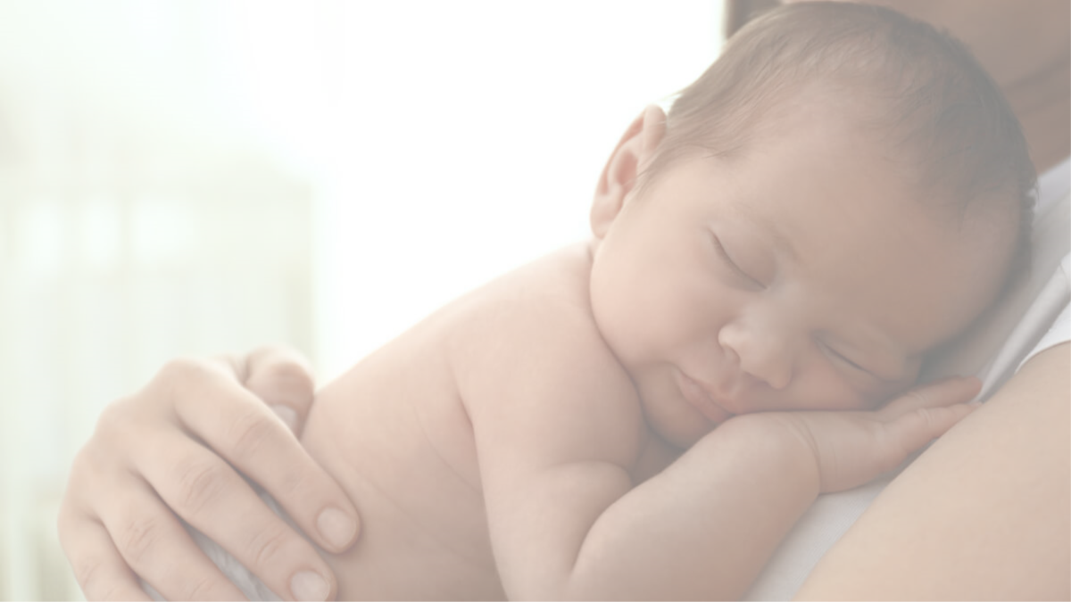

**Maintaining Healthy Relationships After Delivery**

**[Insert Date and Time]**

Please join us to learn a little bit about maintaining healthy relationships after delivery. The gathering will provide useful information and an opportunity to discuss how to maintain healthy relationships after the delivery of a child with:

* Yourself
* Your immediate support system
* Your community

*If you or someone you know is experiencing intimate partner violence, please call the* ***Domestic Violence Hotline at 1-800-799-7233, or Option House at 909-381-3471.***

**Presented by [name], [organization]**

Insert two sentence biography of subject matter expert.

This information is made available in part by support from the Maternal Health Network of San Bernardino County.

Published in 2021. To learn more about the MHN, please visit our website at [www.maternalhealthnetworksb.com](http://www.maternalhealthnetworksb.com).

**Insert Logo and/or Picture of Presenter**